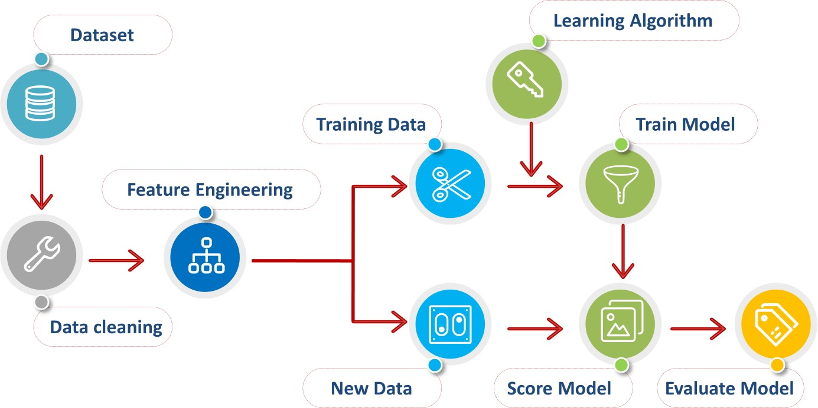

**FACULTY:DR D GANESHA**

ASSIGNMENT-7

**DATA PREPROCESSING**

**SUBMMITED BY: DEEKSHA C 433IS21013**

**ASSIGNMENT-7 DATA PREPROCESSING**

Data preprocessing is the process of cleaning and transforming raw data into a format that is more suitable for analysis or machine learning. It involves various tasks such as:

1. **Data Cleaning:** Removing or handling missing values, correcting errors, and dealing with inconsistencies in the data.
2. **Data Transformation:** Converting data into a consistent format, such as scaling numerical features, encoding categorical variables, and normalizing data.
3. **Data Reduction:** Removing redundant or irrelevant features to reduce the dimensionality of the data.
4. **Data Integration:** Combining data from multiple sources into a single dataset.
5. **Data Sampling:** Selecting a subset of data for analysis, especially in the case of large datasets.
6. **Data Aggregation:** Grouping data to summarize information or create new features.

Data preprocessing is a crucial step in the data analysis and machine learning pipeline, as the quality of the data you use can significantly impact the results and insights you can derive from it.

## Data preprocessing is essential for several reasons:

1. **Data Quality:** Raw data often contains errors, missing values, and inconsistencies. Preprocessing helps clean and correct these issues, ensuring that the data is of high quality.
2. **Data Consistency:** Preprocessing helps standardize the format and structure of the data, making it consistent and suitable for analysis.
3. **Feature Engineering:** Transforming and selecting features can improve the performance of machine learning models by highlighting relevant information and reducing noise.
4. **Dimensionality Reduction:** Removing redundant or irrelevant features can simplify the data and improve model performance, reduce overfitting, and speed up training.
5. **Handling Categorical Data:** Converting categorical variables into numerical representations is necessary for many machine learning algorithms, making them compatible with a wider range of models.
6. **Dealing with Missing Data:** Preprocessing provides strategies to handle missing data, such as imputation, which ensures that the analysis or model training can proceed effectively.
7. **Data Scaling and Normalization:** Scaling numerical features helps algorithms that are sensitive to the scale of variables, while normalization ensures that data follows a specific distribution, which can be important for certain algorithms.
8. **Data Integration:** In many real-world scenarios, data comes from various sources and in different formats. Data preprocessing helps combine and integrate these diverse datasets for a more comprehensive analysis.
9. **Efficiency:** Preprocessing can make data more manageable and reduce computational costs by eliminating unnecessary information.

Overall, data preprocessing is crucial to prepare data for analysis, ensure its quality, and make it suitable for machine learning algorithms. It can significantly impact the accuracy and reliability of the insights or predictions derived from the data.

## Data preprocessing methods encompass a wide range of techniques and procedures to prepare raw data for analysis or machine learning. Here are some common data preprocessing methods:

1. **Data Cleaning:**

* Handling missing values by imputation, deletion, or using advanced techniques.
* Detecting and handling outliers.
* Dealing with duplicate records.

## Data Transformation:

* Encoding categorical variables using techniques like one-hot encoding, label encoding, or binary encoding.
* Scaling numerical features to a standard range (e.g., 0 to 1) or using standardization (z-score normalization).
* Normalizing data to follow a specific distribution (e.g., Gaussian distribution).

## Data Reduction:

* Principal Component Analysis (PCA) for dimensionality reduction.
* Feature selection to choose the most relevant features.
* Binning or discretization of continuous data.

## Data Integration:

* Combining data from multiple sources into a single dataset.
* Handling schema integration and resolving naming conflicts.

## Data Sampling:

* Random sampling to reduce the size of large datasets.
* Stratified sampling to maintain the class distribution in classification tasks.

## Feature Engineering:

* Creating new features based on existing ones.
* Using domain knowledge to derive meaningful features.

## Data Imputation:

- Filling missing values using methods like mean imputation, median imputation, or advanced techniques such as K-nearest neighbors imputation.

## Data Encoding:

* Converting text or categorical data into numerical format.
* Handling ordinal and nominal data differently.

## Data Normalization:

* Scaling features to ensure they have a similar scale.
* Min-Max scaling and z-score normalization are common techniques.

## Data Discretization:

* Binning or grouping continuous data into discrete intervals.
* Useful for decision tree algorithms and certain types of analysis.

## Data Splitting:

- Dividing the dataset into training, validation, and test sets for model training and evaluation.

## Data Imbalance Handling:

- Oversampling minority class, undersampling majority class, or using techniques like SMOTE to address class imbalance.

## Data Aggregation:

- Summarizing data by grouping or aggregating to create new features or reduce granularity.

These methods are applied based on the specific characteristics of the data and the goals of the analysis or machine learning task. The choice of preprocessing techniques can significantly impact the quality of results and insights derived from the data.

# How can we preprocess our data using Scikit learn python module:

Scikit-learn is a powerful Python library for machine learning and data preprocessing. Here's a general outline of how you can preprocess your data using Scikit-learn:

## Import Scikit-learn and Load Your Data:

First, import the necessary Scikit-learn modules and load your dataset using Pandas or any other data loading method.

Python:

import pandas as pd

from sklearn.model_selection import train_test_split

# Load your data

data = pd.read_csv('your_data.csv')

## Handling Missing Data:

If your data has missing values, you can handle them using Scikit-learn's `SimpleImputer` class.

Python:

from sklearn.impute import SimpleImputer

imputer = SimpleImputer(strategy='mean') # Use 'mean', 'median', 'most_frequent', etc. data[['column_with_missing_values']]

imputer.fit_transform(data[['column_with_missing_values']])

## Handling Categorical Data:

For encoding categorical variables, you can use Scikit-learn's `OneHotEncoder` or

`LabelEncoder` depending on the nature of your data. Python:

from sklearn.preprocessing import OneHotEncoder

encoder = OneHotEncoder(sparse=False, drop='first') # Use 'first', 'last', or 'False' data_encoded = encoder.fit_transform(data[['categorical_column']])

## Scaling/Normalizing Data:

Scikit-learn provides tools for scaling or normalizing numerical features. Python:

from sklearn.preprocessing import StandardScaler scaler = StandardScaler()

data[['numerical_column']] = scaler.fit_transform(data[['numerical_column']])

## Splitting Data:

Split your data into training and testing sets using `train_test_split`. Python:

X = data.drop('target_column', axis=1) y = data['target_column']

X_train, X_test, y_train, y_test = train_test_split(X, y, test_size=0.2, random_state=42)

## Other Preprocessing Steps:

Depending on your data and the specific preprocessing steps required, you might need to apply techniques like dimensionality reduction, feature selection, and data aggregation using Scikit-learn modules.

Scikit-learn offers a wide range of preprocessing tools, and the specific steps you need to perform will depend on the characteristics of your dataset and the goals of your analysis or machine learning task. Make sure to refer to Scikit-learn's documentation and modules for more detailed information on each preprocessing task.

# Standard Scaler:

In Scikit-learn, the `StandardScaler` is a preprocessing technique used for standardizing numerical features. Standardization, also known as z-score normalization, transforms your data in such a way that it has a mean of 0 and a standard deviation of 1. This makes the features have a similar scale, which can be beneficial for many machine learning algorithms.

Here's how you can use the `StandardScaler` in Scikit-learn:

1. Import the `StandardScaler` class: Python:

from sklearn.preprocessing import StandardScaler

1. Create an instance of the `StandardScaler`:

Python:

scaler = StandardScaler()

1. Fit the scaler on your data to compute the mean and standard deviation for each feature: Python:

scaler.fit(X_train)

1. Transform your data by applying the scaling to the features:

Python:

X_train_scaled = scaler.transform(X_train) X_test_scaled = scaler.transform(X_test)

After standard scaling, each feature in your dataset will have a mean of approximately 0 and a standard deviation of 1. This can be particularly useful when dealing with machine learning algorithms that are sensitive to the scale of input features, such as support vector machines and k-means clustering. It helps ensure that all features contribute equally to the modeling process and can improve the convergence and performance of these algorithms.

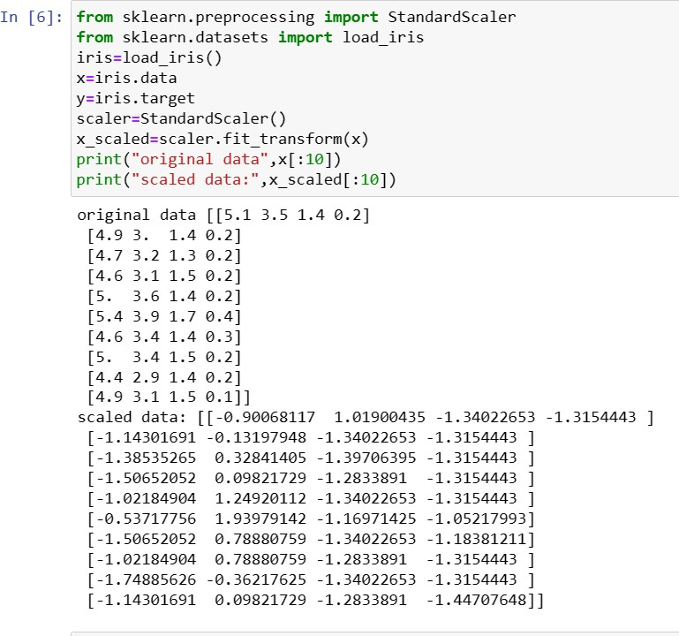

# MinMaxScaler:

The `MinMaxScaler` is a data preprocessing technique in Scikit-learn that is used to scale the features of a dataset to a specific range, typically between 0 and 1. It works by transforming the data in such a way that the minimum value of the feature is mapped to 0, and the maximum value is mapped to 1, while all other values are scaled accordingly.

Here's how you can use `MinMaxScaler` in Scikit-learn: Python:

from sklearn.preprocessing import MinMaxScaler # Create a MinMaxScaler instance

scaler = MinMaxScaler()

# Fit the scaler to your data and transform the data

X_scaled = scaler.fit_transform(X) In this code:

1. You import `MinMaxScaler` from Scikit-learn's `preprocessing` module.
2. You create an instance of the `MinMaxScaler` class.
3. You fit the scaler to your data using the `fit_transform` method, which scales the features in the dataset according to the minimum and maximum values of each feature.

Using `MinMaxScaler` is beneficial when you want to ensure that all your features are on the same scale, particularly for machine learning algorithms that are sensitive to the scale of input features. It's important to note that while it scales the data, it doesn't change the distribution or relative distances between data points, so it's particularly useful for maintaining the interpretability of your data.

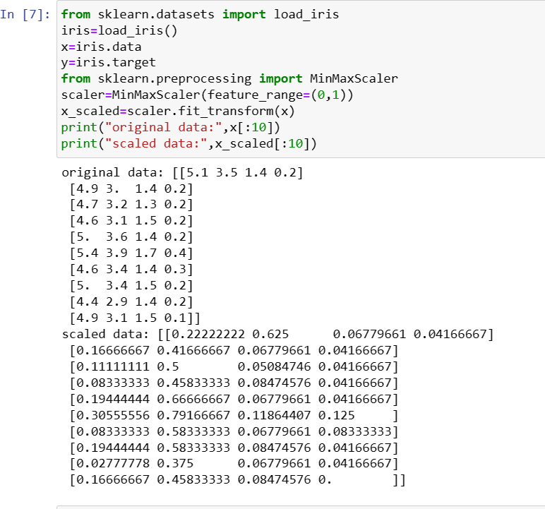

# Normalizer:

In scikit-learn (sklearn), a normalizer is a preprocessing step that scales and normalizes the features (input data) for machine learning models. It ensures that each sample (row) in your dataset has the same scale, making it easier for machine learning algorithms to learn from the data.

Scikit-learn provides a `Normalizer` class that can be used to perform this operation. The

`Normalizer` applies L2 normalization by default, which scales each sample (row) so that its Euclidean norm (L2 norm) is equal to 1. You can also specify different norms (e.g., L1 norm) using the `norm` parameter.

Here's an example of how to use the `Normalizer` in scikit-learn:

python

from sklearn.preprocessing import Normalizer import numpy as np

# Create a sample dataset X = np.array([[1.0, 2.0],

[3.0, 4.0],

[5.0, 6.0]])

# Create a Normalizer instance normalizer = Normalizer()

# Fit and transform the data X_normalized = normalizer.transform(X) print(X_normalized)

The `X_normalized` array will contain the normalized values of the input data, and each row will have a Euclidean norm (L2 norm) equal to 1. This preprocessing step can be particularly useful

when working with machine learning algorithms that are sensitive to the scale of the input features, such as K-nearest neighbors (KNN) or clustering algorithms.

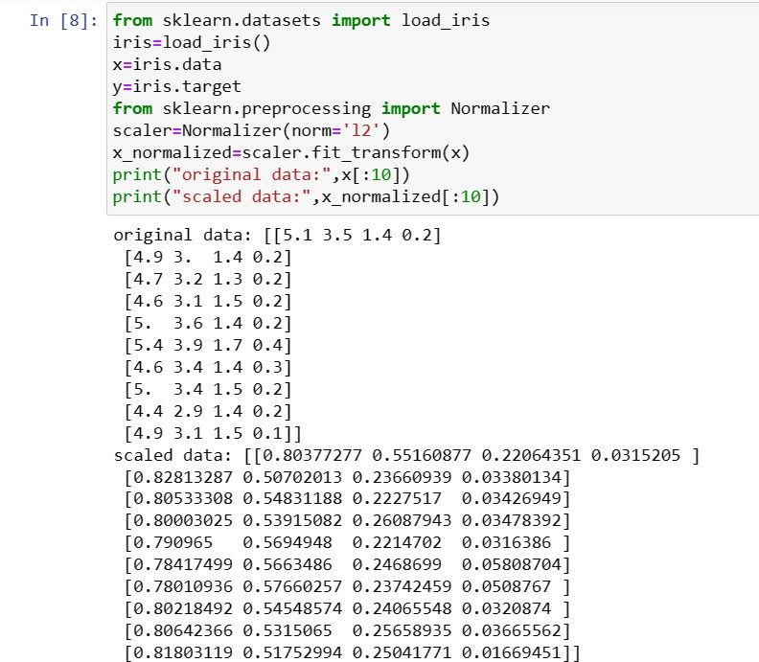

# Onehotencoder:

In scikit-learn (sklearn), `OneHotEncoder` is a preprocessing technique used for converting categorical variables into a numerical representation, specifically a one-hot encoded format. Categorical variables are those that represent categories or labels, like "red," "green," "blue" for a color category or "cat," "dog," "fish" for an animal category.

One-hot encoding is a process that transforms categorical variables into binary vectors. For each category in the original variable, it creates a binary column (0 or 1) in the output, where 1 indicates the presence of that category, and 0 indicates the absence. This is useful for machine learning algorithms that work with numerical data.

Here's an example of how to use the `OneHotEncoder` in scikit-learn: Python:

from sklearn.preprocessing import OneHotEncoder import numpy as np

# Create a sample dataset with categorical data data = np.array([['cat'],

['dog'],

['fish'],

['cat'],

['dog']])

# Create a OneHotEncoder instance encoder = OneHotEncoder()

# Fit and transform the data

one_hot_encoded = encoder.fit_transform(data) # The resulting one-hot encoded array print(one_hot_encoded.toarray())

In this example, the `one_hot_encoded` array will represent the original categorical data as one-hot encoded binary vectors. Each unique category gets its own binary column, and the presence of the category is indicated by a 1 in the corresponding column.

`OneHotEncoder` is often used as a preprocessing step before applying machine learning algorithms that can't work with categorical data directly, like linear regression or support vector machines. It helps preserve the information from categorical variables while making it suitable for numerical-based models.

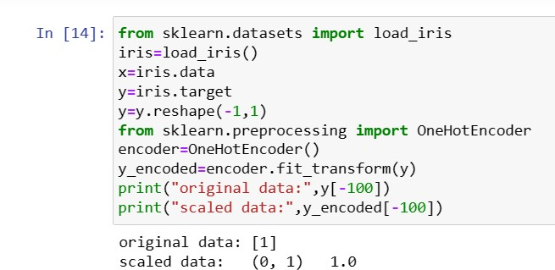

# Labelencoder:

A Label Encoder is a preprocessing technique used in machine learning to convert categorical labels (text-based labels) into numerical labels. It assigns a unique integer to each category or label in a categorical variable. This is useful when working with machine learning algorithms that require numerical input, as it transforms the categorical data into a format that can be used for training models.

Here's a simple example of how a Label Encoder works in Python using scikit-learn: Python:

from sklearn.preprocessing import LabelEncoder # Sample categorical data

categories = ['red', 'green', 'blue', 'red', 'green'] # Create a LabelEncoder instance

encoder = LabelEncoder()

# Fit and transform the data

encoded_labels = encoder.fit_transform(categories) print(encoded_labels)

In this example, `encoded_labels` will contain numerical labels corresponding to the original categories. The labels are assigned in an alphabetical order. So, 'blue' might be encoded as 0, 'green' as 1, and 'red' as 2.

It's important to note that while Label Encoding is a straightforward way to convert categorical data to numerical form, it may not always be suitable for all machine learning algorithms, especially when the categorical variable doesn't have an inherent order or when the encoding implies an ordinal relationship between the categories. In such cases, One-Hot Encoding (as explained in a previous response) is often preferred, as it creates binary columns for each category, avoiding any unintended ordinal relationships.

